

**Project 3**

Mapping and perception for an autonomous robot/ 0510-7591

By

Nimrod Curtis

Tel Aviv University  
Spring 2023

**Contents**

1. Introduction 2

2. Solution 2

1. Particle Filter 2

2. ICP 13

3. Visual Odometry 23

3. Summary 30

**Figures**

Figure 1 - odometry motion model 3

Figure 2 - GT trajectory & Landmarks 3

Figure 3 - Noise trajectory & Landmarks 5

Figure 4 - Low-Variamce Resampling algorithm 6

Figure 5 - Frame 0, N=1000 7

Figure 6 - Frame 1 , N=1000 7

Figure 7 - Frame 5 , N=1000 8

Figure 8 - Frame 20 , N =1000 8

Figure 9 - Frame 100, N=1000 9

Figure 10 - Frame 325, N = 1000 9

Figure 11 - Frame 320, N = 500 10

Figure 12 - Frame 320, N = 100 11

Figure 13 - Frame 320 , N = 75 11

Figure 14 - Frame 320, N = 70 12

Figure 15 - case 1 -Frame A (5) 15

Figure 16 - case 1 - Frame B (9) 15

Figure 17 - case 1 - Full clouds - before ICP 16

Figure 18 - case 1 - Aproximate distance 16

Figure 19 – case 1 - Filtered clouds - before ICP 17

Figure 20 - case 1 - ICP errors 19

Figure 21 - case2 - Frame A (10) 20

Figure 22 - case2 - Frame B (15) 20

Figure 23 - case 2- Full clouds - before ICP 21

Figure 24 - case 2 - Aproximate distance 21

Figure 25 – case 2 - Filtered clouds - before ICP 22

Figure 26 - case 2 - ICP errors 23

Figure 27 - Frame 500 , GT vs. Estimation 26

Figure 28 - Last frame 27

Figure 29 - Frame 2000 28

Figure 30 - Frame 250 28

Figure 31 - Dynamic object example 30

Figure 32 - Repeatative regions filtering example 30

# Introduction

This robotics mapping and localization assignment explores three key topics: Particle Filter, Iterative Closest Points (ICP), and Visual Odometry. In the Particle Filter section, the focus is on implementing a particle filter algorithm to estimate the robot's pose by incorporating motion model predictions and sensor measurements. The ICP section involves implementing the ICP algorithm to align two scans and analyzing the results under different conditions. Lastly, the Visual Odometry section aims to develop a monocular visual odometry pipeline for estimating camera motion and addressing drift issues. The assignment provides guidelines, data, and evaluation metrics to assess the performance of each algorithm and suggests potential improvements.

# Solution

## Particle Filter

The task at hand revolves around the implementation and utilization of particle filters in the field of autonomous robotics. Particle filters are a powerful probabilistic estimation technique that enables the sampling and representation of distributions through a collection of particles. This methodology allows for the prediction and update of distributions based on motion models, measurements, and their associated uncertainties. By forward predicting each particle using the motion model, generating a prediction of the distribution, and subsequently comparing and updating it using measurements, particle filters provide an effective approach for estimating and tracking the state of a system in autonomous robotics applications.

On this task, particle filter method was implemented based on landmarks data and true odometry data of the mobile vehicle

#### Dataset

The dataset consist of two arrays.

* Landmark Positions: This array contains the $[x,y]$ coordinates of various landmarks. The positions are obtained from the data provided in the LastID_6.csv file (I tried various of scenarios from the dataset and by mistake I stayed with case 6 instead of 4 for the analysis).
* GT Trajectory: This array represents the $\left[x,y,θ\right]$ coordinates of the vehicle's trajectory. The vehicle's position and orientation are determined using the odometry model ${[δ}_{r1},δ_{trans}, δ_{rot2}]$ at each timestamp.

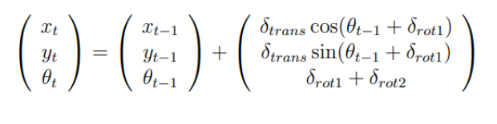

Figure - odometry motion model

As said, the ground truth trajectory calculated and can be seen as below:

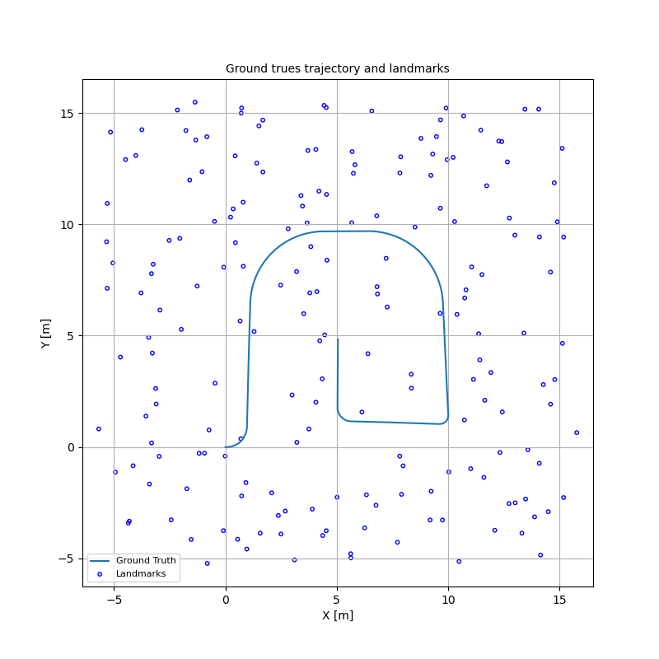

Figure - GT trajectory & Landmarks

The GT trajectory plays a crucial role in determining the accurate distances between the particles and the landmarks. It also contributes to the evaluation section of the analysis.

#### Sensor measurement

In the task, a 2D LiDAR sensor with a single layer and 360-degree coverage was assumed. During each iteration, the sensor calculated the range and azimuth (r, φ) values exclusively from the nearest landmarks. The sensor measurement noise (Q) was characterized by a range standard deviation $σ_{r}= 1$ and an azimuth standard deviation $σ_{φ}= 0.1$. These parameters were utilized to analyze the performance and accuracy of the sensor in measuring distances and angles to the closest landmarks. The results and findings have been presented in the report.

#### PF – Implementation

* Initialization

In the experiment, an array of particles was initialized for analysis. The array consisted of N particles, with $N= 1000 \left[particles\right]$. The starting point of the robot was defined as $(x_{0}, y_{0}, θ_{0})$, and a hypothesis pose was generated for each particle based on specific initial distributions.

$$x_{0}\sim N\left(0,2\right), y_{0}\sim N\left(0,2\right),θ_{0}\sim N(0.1,0.1)$$

These initial distributions were employed to establish the starting positions for each particle and to analyze their subsequent behavior throughout the experiment.

Initial weights were assumed to be uniform based on the particle filter, therefore:

$$weight_{particle_{i}}=\frac{1}{N}$$

For drawing the path of the trajectory, the best particle at each timestamp was stored in a history array.

* Noise odometry

Noise in the odometry data was added to the ground truth odometry.

$$σ_{rot1}=0.01, σ_{trans}=0.2, σ_{rot2}=0.01$$

Then based on the odometry motion model (see Figure 1) can be presented as follow:

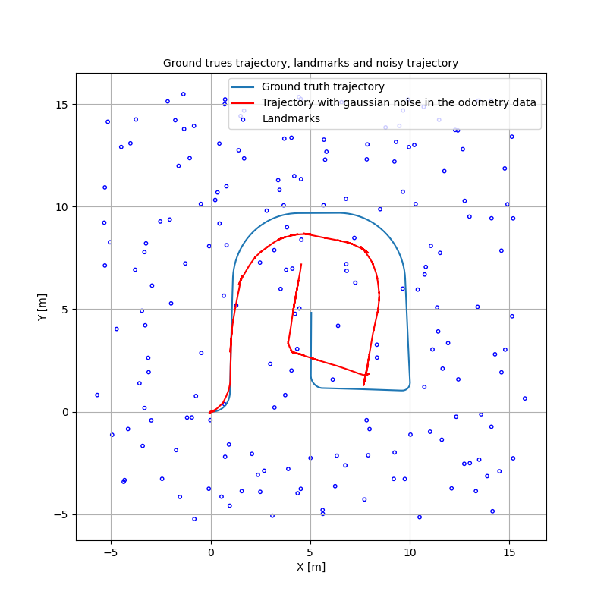

Figure - Noise trajectory & Landmarks

* Sensor measurement and correction implementation

relative to the nearest landmark, similar calculations were performed for each particle. The similarity between the ground truth measurement and the particle's calculation was assessed using the Mahalanobis distance technique. This distance-based approach was utilized to update the weights of the particles based on the computed distance values.

Given:

$x_{GT} =\left(r_{GT},θ_{GT}\right),μ_{particle_{measure}}=\left(r_{μ},θ_{μ}\right), S= \left[\begin{matrix}σ_{r}^{2} & 0 \\ 0 & σ_{θ}^{2}\end{matrix}\right]$

Where $S$ is the covariance matrix representing the measure noise.

$$d_{mahanabolis}= \sqrt{\left(x-μ\right)S^{-1}(x-μ)}$$

So the weight can be updated by the multi-variate normal equation:

$$W_{i}=\frac{1}{2π\sqrt{\left|S\right|}}e^{-0.5*d_{mahanabolis}}$$

* Resampling

Resampling processed was implemented by using the Low-Variance sampling algorithm.

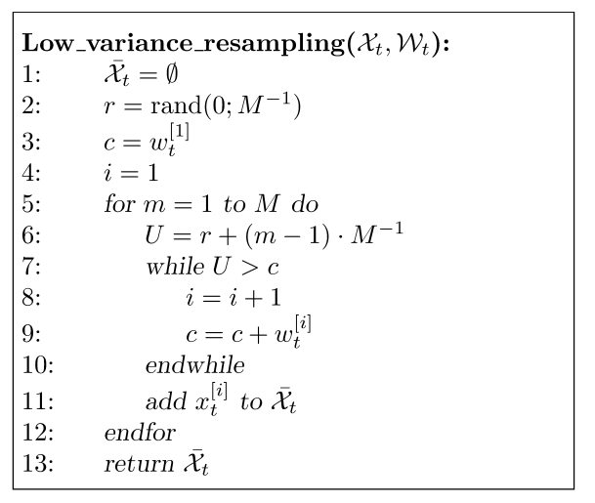

Figure - Low-Variamce Resampling algorithm

* Robot Pose

The best particle pose, A.K.A the particle with the best weight, was estimated as the robot final pose at the specific iteration.

#### Analysis and Results

##### Main steps illustration for N=1000 particles.

Due to the initial uniform distribution of particles in the first frame, there is a possibility of certain particles receiving the highest weight despite not accurately representing the true position of the robot.

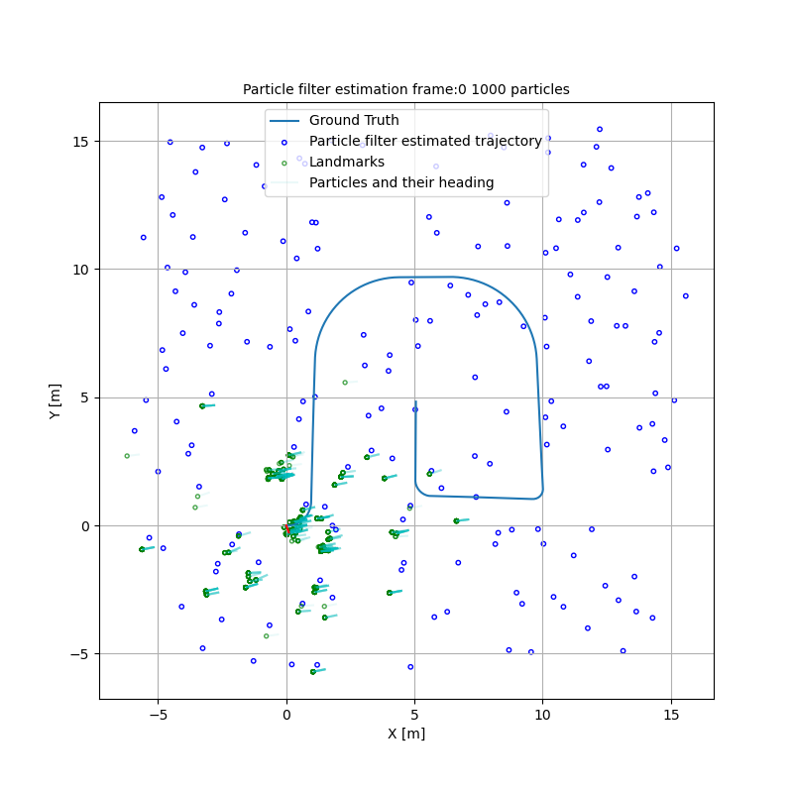

Figure - Frame 0, N=1000

Consequently, the robot may be placed in an incorrect location on the next iteration, based on these weights.

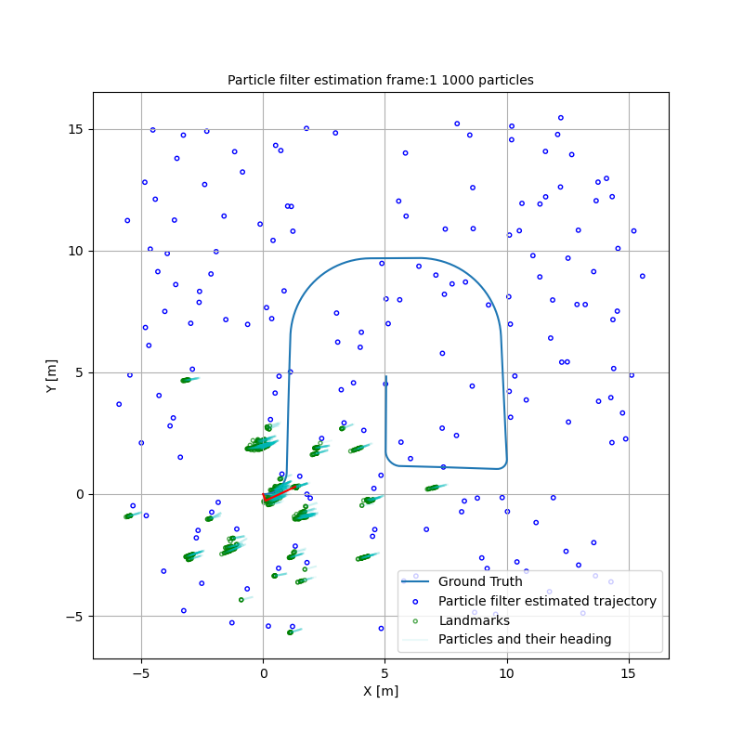

Figure - Frame 1 , N=1000

As the iterations progress, new particles are resampled to the areas where particles with the highest weights are present. These areas are visually get strengthened with green color of the particles in the figures.

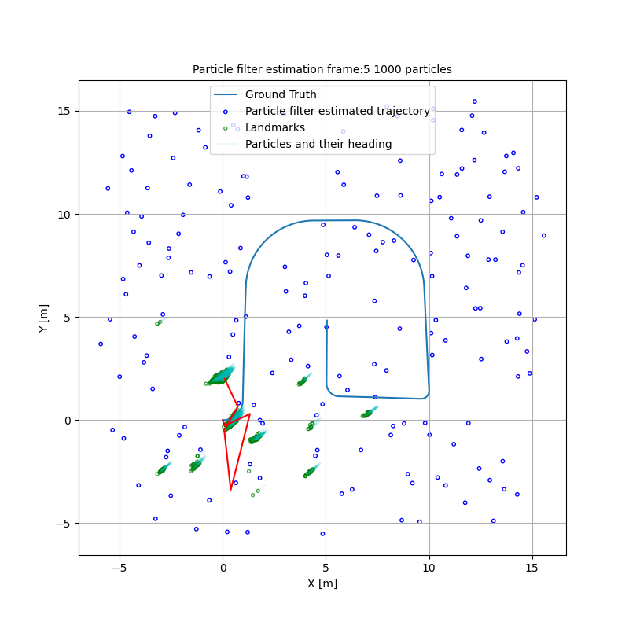

Figure - Frame 5 , N=1000

By iteratively updating the particle weights and resampling particles according to their weights, the robot gradually refines its estimate of the trajectory. The correct trajectory emerges as the particles with higher weights converge towards the ground truth trajectory, indicating the discovery of the correct path by the robot. On this case, convergence occurred approximately on frame 20 as can seen below:

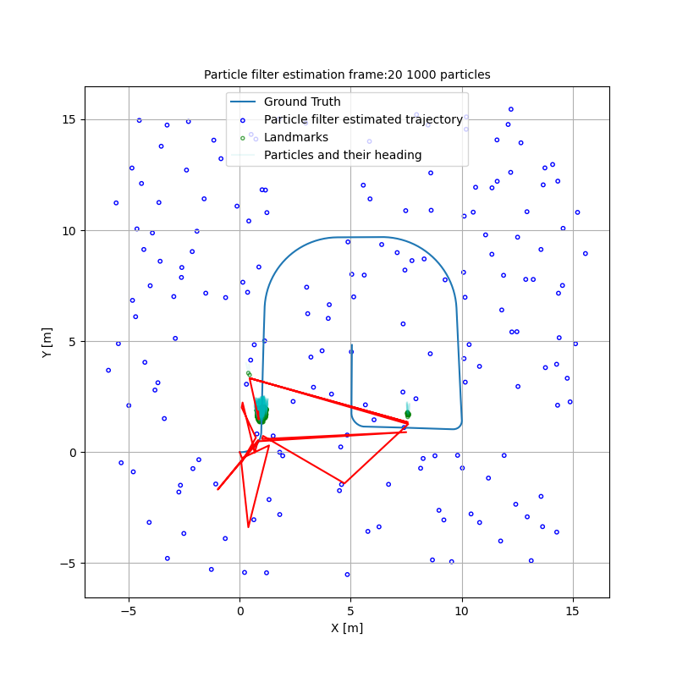

Figure - Frame 20 , N =1000

After multiple iterations, the majority of particles will converge to the ground truth (GT) area with minimal variance, resulting in an estimated trajectory that still exhibits a zigzag.

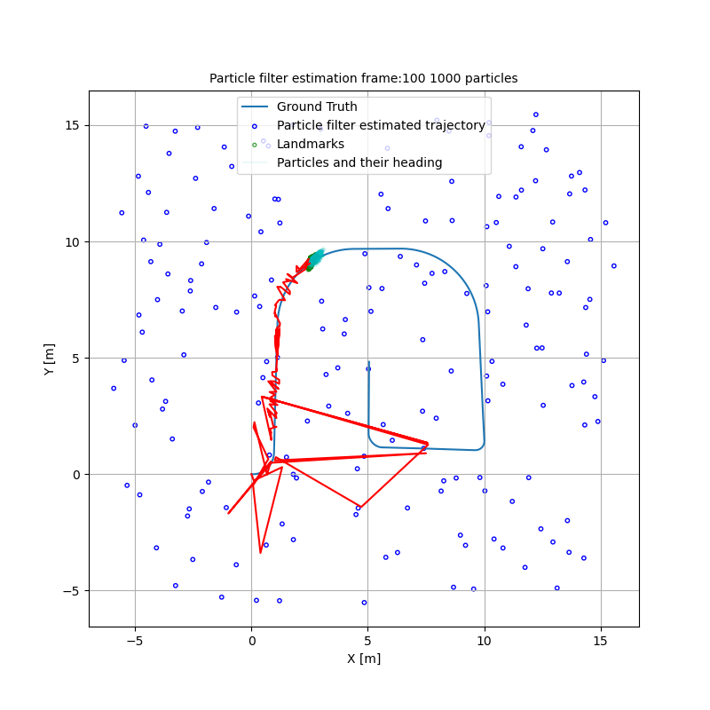

Figure - Frame 100, N=1000

Final estimate trajectory:

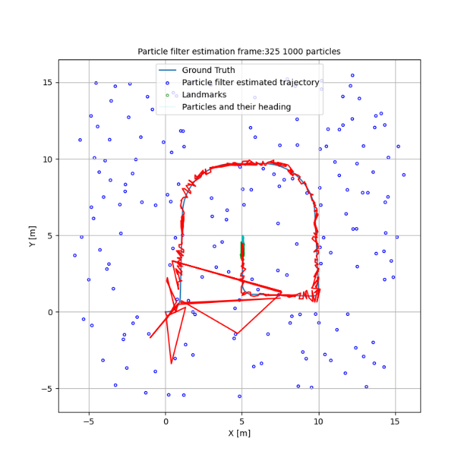

Figure - Frame 325, N = 1000

It can be seen quite clearly that the estimated trajectory is around the true trajectory quite well for this case.

##### MSE error

Given:

$$N=1000\left[particles\right],{frame}_{start}=10$$

The MSE is:

$$MSE_{10}=0.613[m]$$

Notable errors were observed in the initial frames when the trajectory had not yet converged. By frame 10, significant errors persisted, which had an impact on the final error calculation. However, despite these errors, the overall error remained relatively small. The error after convergence at ~frame 20 is:

$$MSE_{20}=0.093[m]$$

##### Minimal set of particles

For finding the minimal set of particles that still maintain a good performance as determined by the MSE criteria, a several runs were conducted.

* 🡪

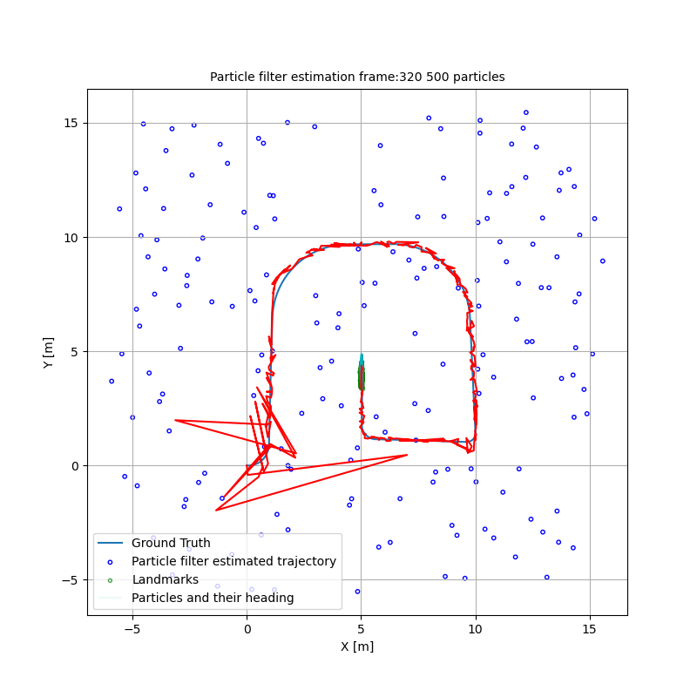

Figure - Frame 320, N = 500

* 🡪

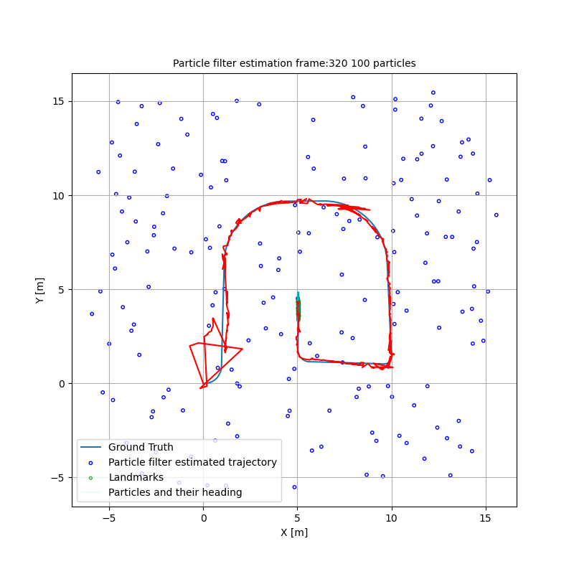

Figure - Frame 320, N = 100

* 🡪

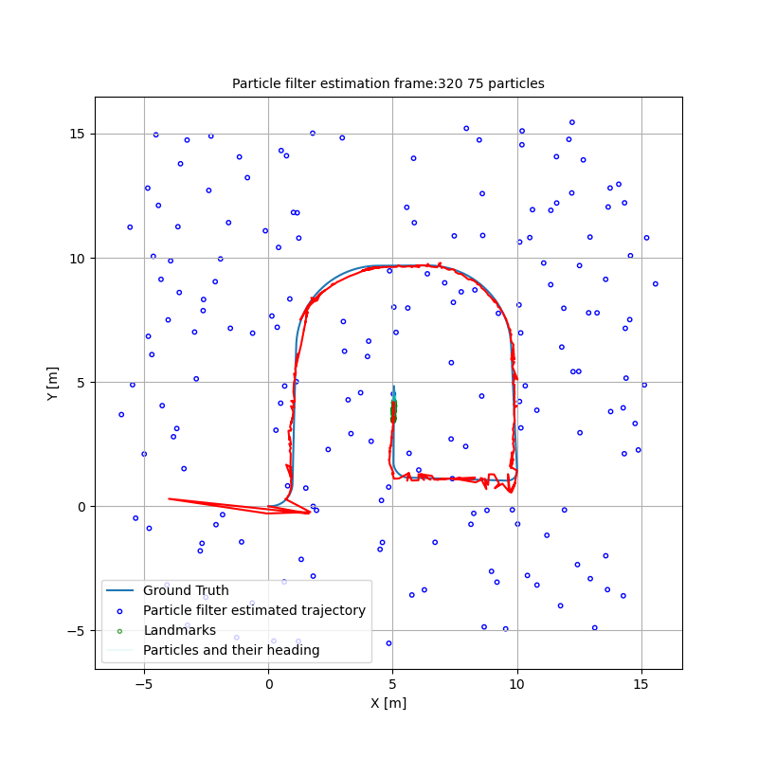

Figure - Frame 320 , N = 75

For the given initial conditions, given this dataset and seed, the minimal set of particles seems to be approximately 75 particles.

Below this number of particles the trajectory appears to be unstabilize.

* 🡪

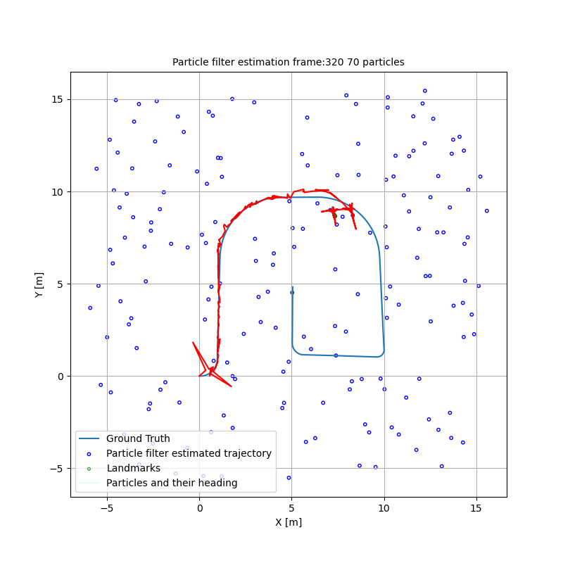

Figure - Frame 320, N = 70

For summary, from the results above we can see that decreasing the number of particles in estimation can potentially lead to improved results. This is because reducing the number of particles allows for a more concentrated and focused representation of the possible states or poses of the robot.

When the number of particles is reduced, each individual particle carries more significance in the estimation process. In addition, decreasing in the number of particles led to faster execution times because of less complexity.

On the other hand, if the number of particles is too low, the estimation may become overly sensitive to outliers or measurement noise, leading to less accurate results.

##### Pros & Cons – PF

Pros of Particle Filters:

1. Particle filters can handle nonlinearities in system models and measurements, making them suitable for real-world applications.

2. Particle filters can estimate non-Gaussian distributions, improving accuracy in modeling uncertainties.

Cons of Particle Filter Algorithm:

1. Particle filters can be computationally demanding, especially with a large number of particles or in high-dimensional state spaces. This can result in slower execution times and resource limitations.

Improvement Suggestion:

* Utilize parallelization techniques for efficient distribution of computations.

2. Particle degeneracy occurs when only a few particles have significant weights, leading to a loss of diversity and accuracy in estimation.

Improvement Suggestions:

* Use advanced resampling techniques to preserve particle diversity during resampling.

## ICP - Iterative Closest Point

In this project section, the objective was to implement an ICP routine for aligning two point clouds obtained from the KITTI dataset. The Iterative Closest Point (ICP) process is a widely used algorithm in the field of robotics and computer vision for aligning two sets of 3D point clouds or 2D point sets. The goal of ICP is to find the optimal transformation (translation and rotation) that aligns the points from one set with the corresponding points in the other set, minimizing the overall distance between them.

#### Vanilla ICP algorithm

The steps involved in the ICP process includes:

* **Initialization**: Providing an initial estimate of the transformation between 'frame 1' to 'frame 2' (designated as the base).
* **Data Association**: Matching points from one set with the closest points in the other set.

This was done by using the KDtree algorithm.

* **Transformation Estimation**: Estimating the transformation (rotation & translation matrices) that aligns the sets by minimizing the distance between corresponding points.

This was done by shifting the pointclouds based on their means. Then the rotation and translation matrices could be extracted by the SVD algorithm.

* **Iteration**: Repeating the data association, correspondence estimation, and transformation estimation steps until convergence.
* **Termination**: Ending the iteration process based on a convergence criterion or maximum number of iterations (=50 In our case).

#### Implementation and Analysis – ICP – Case: record 2011_09_26/0117 cloud 5->9

In this section the ICP algorithm was used to align pointcloud of frame 5 to pointcloud of frame 9 from the record of 2011_09_26/0117 from KITTI dataset.

Different mechanisms and conditions were used for the implementation of the ICP.

* Full point cloud with associations pairs based on KDTree
* Filtered point cloud with associations pairs based on KDTree
* Filtered point cloud with associations pairs based on Nearest Neighbors

##### Pre-scan correction

Frame A = 5 :

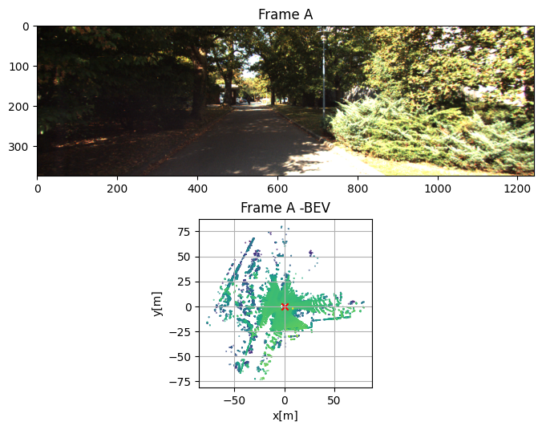

Figure - case 1 -Frame A (5)

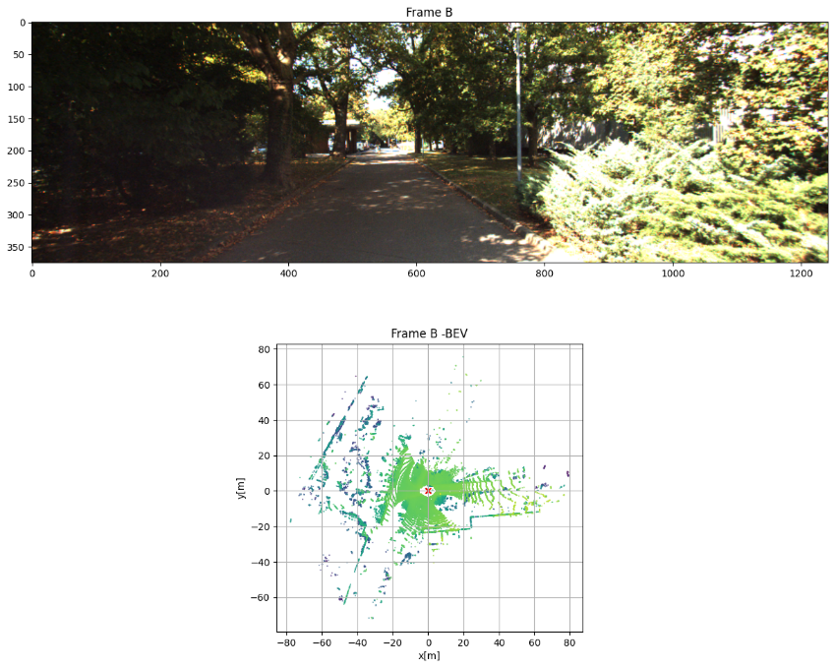

Figure - case 1 - Frame B (9)

We can see that the vehicle is in a park environment with a trees and bushes surround the roads.

In addition from frame A to frame B there we can observed the movements occurred mainly in the x-direction which means the car moved forward. This can be said by the fact that the vehicle got closed to the objects surrounding the road, for example like the pillars in the red circles.

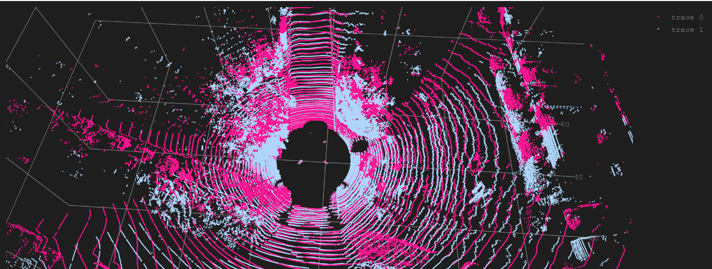

Figure - case 1 - Full clouds - before ICP

In this figure we can see the full pointclouds of the frames. The pink cloud is frame A cloudsand the gray cloud is frame B cloud which is shifted closer to the vehicle in relate to the X-axis (the red arrow).

This can be seen with more details in the figure below:

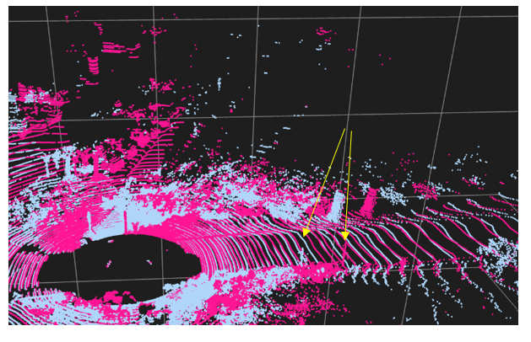

Figure - case 1 - Aproximate distance

In the image depicted above, the movement with respect to the previously mentioned roadside pillars is visible. Furthermore, the approximate gap between the two clusters of clouds was manually computed, resulting in a measurement of approximately 2.5-3.5 meters.

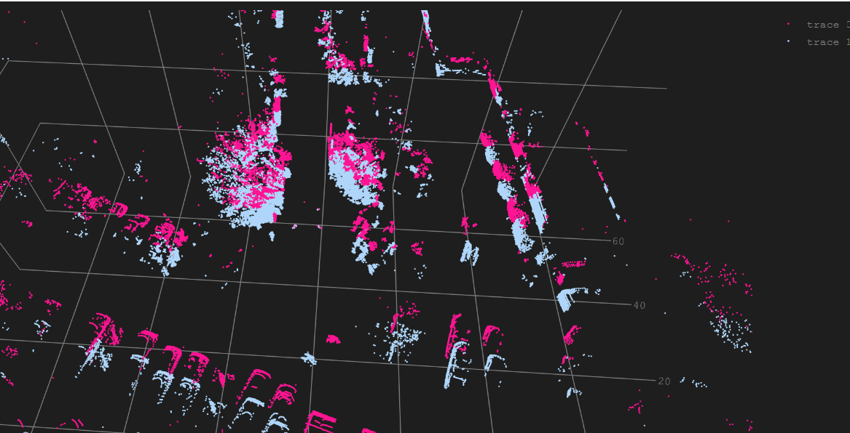

Figure – case 1 - Filtered clouds - before ICP

In the second and the third method a filtered cloud was used. Filter pc include the points only above a minimal height of 1 meter. It means that most of the road points, that possibly add some noises, were eliminated. Now we can see in the figure objects separated in a better way.

##### Final scan corrections – After ICP

Rotation matrix initialize with identity matrix:

$$R=identity_{3X3}$$

Translation matrix initialize with vector of ones:

$$T=[1,1,1]$$

Animations of the ICP process for every case were saved in the results folder. In all of the animations we can see very clearly the transformation applied on frame B cloud, trying to minimize the error every step. Differences in the results and animations were explained on the next sections.

##### Comparison – Full PC vs. Filtered PC

Results table of the full PC vs. the filtered PC can be seen below:

Table – case 1- Full PC vs. Filtered PC

|  |  |  |
| --- | --- | --- |
|  | **Full PC (KD tree)** | **Filtered PC (KD tree)** |
| **Number of Iterations** | 38 | 16 |
| **Convergence time [sec]** | 22.3116 | 3.326 |
| **Error [m]** | 0.550 | 0.797 |

Main conclusions:

* The convergence of ICP on the filtered clouds occurred faster - requiring fewer iterations compared to the application on the full point cloud. This indicates that the estimated transformation affect the error in less iterations compare to the full PC case. This convergence can be attributed to the reduction in noise, which reduces errors and prevents the ICP loop from being prolonged.
* ICP applied to the filtered point clouds exhibited a faster processing speed compared to the full point cloud. This improvement in speed was achieved by the fast converge and by reducing the complexity based on the number of points present.
* The application of ICP to the filtered point clouds resulted in a higher final error in terms of the distances between the point clouds. This can be attributed to the assumption that the KDtree algorithm, when applied to the full point cloud, identifies indices of neighboring points that are closer in proximity, including road points that may not necessarily correspond to the true matching points.

##### Comparison – KDtree vs. Nearest-Neighbors

NOTES:

* KDtree executed by the KDtree function of scikit-learn, setting the leaf size parameter to 120.
* Nearest-Neighbors executed using the same function but with the leaf size parameter equal to 1. By setting the leaf size to 1, it means that each leaf node in the KDtree will store only one point from the dataset, resulting in a more fine-grained partitioning of the space equal to the nearest-neighbor approach.

Results table of the KDtree vs. the NN can be seen below:

Table – case 1 - KDtree vs. NN

|  |  |  |
| --- | --- | --- |
|  | **KD tree (Filtered PC)** | **NN (Filtered PC)** |
| **Number of Iterations** | 16 | 16 |
| **Convergence time [sec]** | 3.326 | 4.653 |
| **Error [m]** | 0.797 | 0.797 |

Main conclusions:

* Both KDtree and NN, converged after the same number of iterations with same error, probably finding the same corresponding points.
* The convergence time of the KDtree was faster. Larger leaf sizes reduce the overall number of nodes in the tree, resulting in a shallower tree structure. This reduces the number of tree traversals required during search operations, leading to faster query times. With fewer nodes to examine, the algorithm can quickly determine the nearest neighbors or perform other spatial operations.

##### Final results

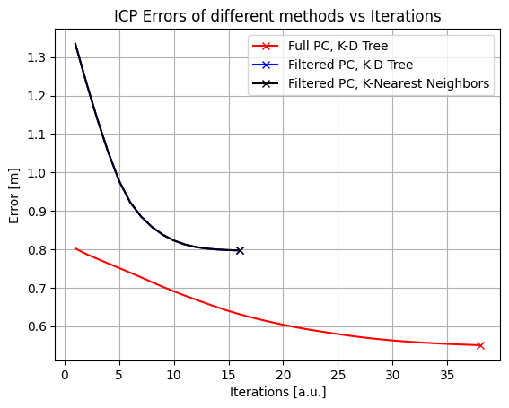

Figure - case 1 - ICP errors

The error plots of various methods were generated. These plots provide a more detailed understanding of the points discussed in the previous sections. In the filtered cases, the errors and convergence rates were identical, but there were variations in computational speed based on the data association method. On the other hand, the Full PC case reached a better value of convergence, albeit requiring more iterations.

In general, there is a noticeable alignment between the point clouds after applying the ICP process in all cases. This alignment is evident through a common cloud structure that appears visually normal after the transformations. Furthermore, the numerical results of the final transformation provide further validation for our hypothesis regarding the shift in the X axis, which was approximately 3 meters (specifically obtained as around 3.3 - 3.5 meters) depending on the method used.

However, it is observed that there are relatively poorer or less comprehensible alignments for distant points. This can be attributed to the sensor's functioning, which generates sparse layers of points as the distance increases. These points may be considered outliers in the alignment process. These outliers can significantly impact the alignment process by exerting a strong influence on the overall alignment, pulling the estimated transformation towards incorrect positions.

Furthermore, in the case of the full point cloud which encompasses the points on the road, there is a potential for partial overlap of those road points, and it can lead to ambiguities in point correspondences In such cases, incorrect correspondences between points from different surfaces or structures can occur, introducing errors in the estimated transformation.

#### Implementation and Analysis – ICP – Case: record 2011_09_26/0113 cloud 10->15

In this section the ICP algorithm was used to align pointcloud of frame 10 to pointcloud and frame 15 from the record of 2011_09_26/0113 from KITTI dataset.

Same mechanisms and conditions from section b were used for the implementation of the ICP.

##### Pre-scan correction

Frame A = 10 :

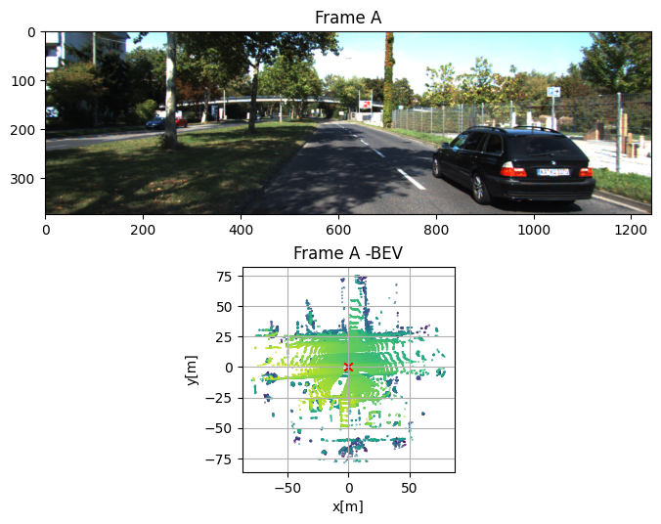

Figure - case2 - Frame A (10)

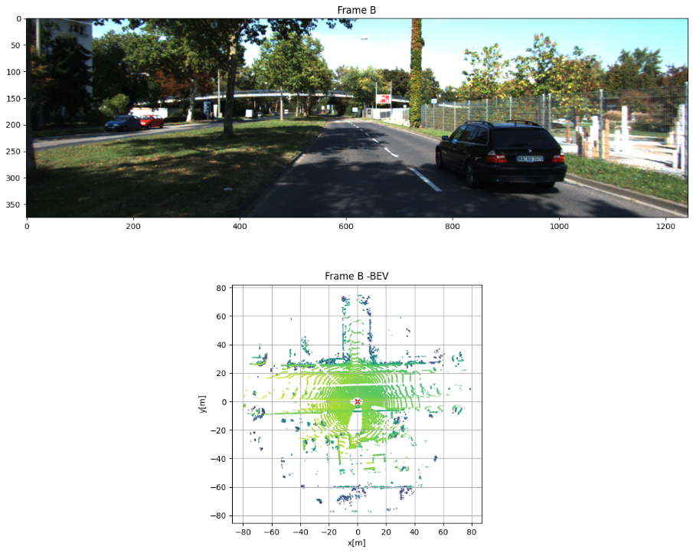

Figure - case2 - Frame B (15)

We can see that the vehicle is in a urban environment with a trees and fences surround the roads.

In addition, important object the presented here is the dynamic car in front of the vehicle.

From frame A to frame B we can observed the movements occurred mainly in the x-direction which means the car moved forward. This can be said by the fact that the vehicle got closed to the **static** objects surrounding the road, for example like the tree in the yellow circle , while maintaining a certain distance from the **moving** vehicle.

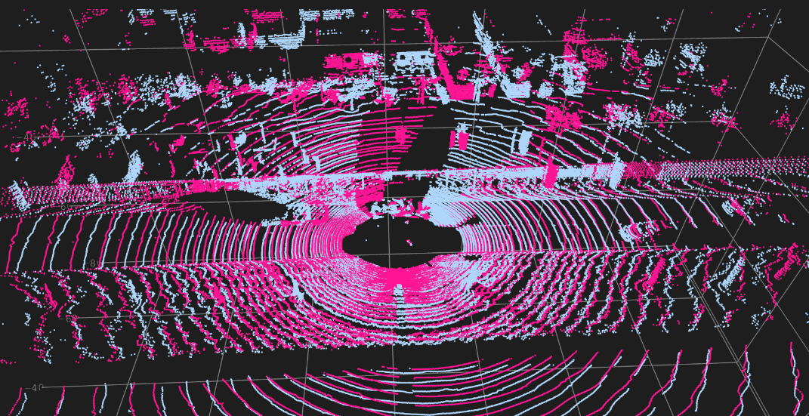

Figure - case 2- Full clouds - before ICP

In this figure we can see the full pointclouds of the frames. The pink cloud is frame A cloud and the gray cloud is frame B cloud which is shifted closer to the vehicle in relate to the X-axis (the orange arrow).

Here, in addition to the camera images, you can probably recognize another dynamic vehicles, one on the right, and two from behind also in red circles.

Also, it is important to note, the fence (green arrow) that is a repetitive feature and could probably has a bad affect on the results because of the overlapping areas, similar to the road.

In comparison to case 1 (0117) we can see here the influence of the dynamic objects. In the case of dynamic cars, it is observed that even after the vehicle moves forward, their point clouds exhibit some degree of overlap, leading to occlusion and introducing specific noise in the surrounding road area.

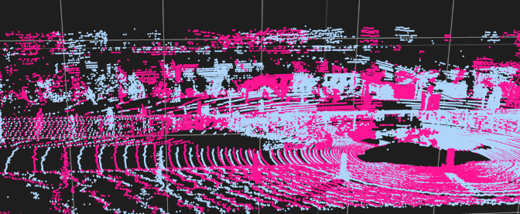

Figure - case 2 - Aproximate distance

In the image depicted above, the movement with respect to the previously mentioned roadside trees is visible. Furthermore, the approximate gap between the two clusters of clouds was manually computed, resulting in a measurement of approximately 6 meters on the x-axis.

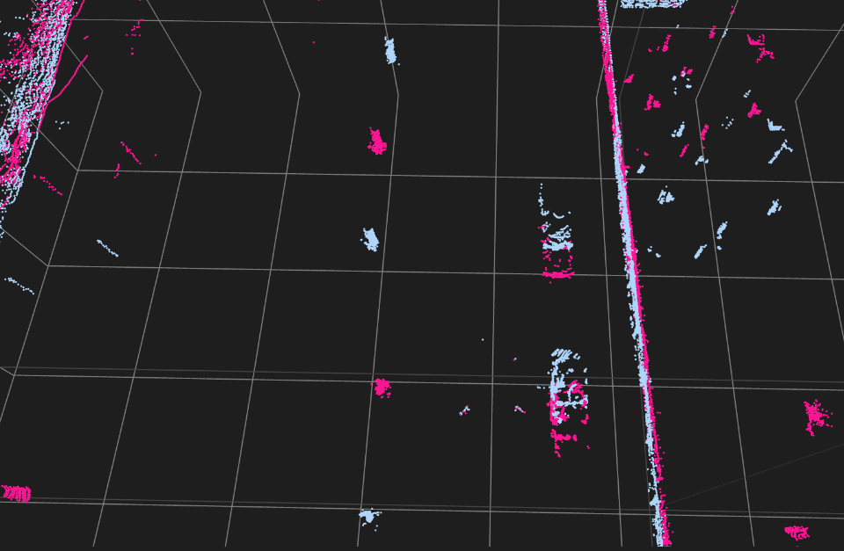

Figure – case 2 - Filtered clouds - before ICP

In the second and the third method a filtered cloud was used. Filter pc include the points only above a minimal height of 1 meter. Now we can see in the figure objects separated in a better way, especially the static objects, while the dynamic cars are more or less overlap, but still with much less noise around the overlapping area because of the filtering.

##### Final scan corrections – After ICP

Rotation matrix and translation vector initialized with the same values as section b.

Animations of the ICP process for every case were saved in the results folder. In all of the animations we can see very clearly the transformation applied on frame B cloud, trying to minimize the error every step. Differences in the results and animations were explained on the next sections.

In this case, for the implementation on full pc, it is already important to note that a bad result was obtained. This result discussed in the next sections.

##### Comparison – Full PC vs. Filtered PC

Results table of the full PC vs. the filtered PC can be seen below:

Table - case2 - Full PC vs. Filtered PC

|  |  |  |
| --- | --- | --- |
|  | **Full PC (KD tree)** | **Filtered PC (KD tree)** |
| **Number of Iterations** | 10 | 31 |
| **Convergence time [sec]** | 5.8986 | 3.603 |
| **Error [m]** | 0.925 | 1.529 |

Main conclusions:

* In this case, the convergence of ICP on the full clouds occurred faster – less iterations. This could
* ICP applied to the filtered point clouds exhibited a faster processing speed compared to the full point cloud. It means the estimation of transformation lost it affect after less iteration, probably as a result of a large amount of pairs of points that were associated in a bad way. Such as the fence, road and the dynamics object.
* The application of ICP to the filtered point clouds resulted in a higher final error in terms of the distances between the point clouds. See section b and the explanation above.
* Despite the lower error of full PC ICP, the final transformation matrix obtained is far from reality while for the filtered PC ICP it is closer to the true matrix.

##### Comparison – KDtree vs. Nearest-Neighbors

Results table of the KDtree vs. the NN can be seen below:

Table – case 2 - KDtree vs. NN

|  |  |  |
| --- | --- | --- |
|  | **KD tree (Filtered PC)** | **NN (Filtered PC)** |
| **Number of Iterations** | 31 | 31 |
| **Convergence time [sec]** | 3.603 | 4.98 |
| **Error [m]** | 1.529 | 1.529 |

In this scenario, the conclusions drawn are analogous to those in section b.

##### Final results

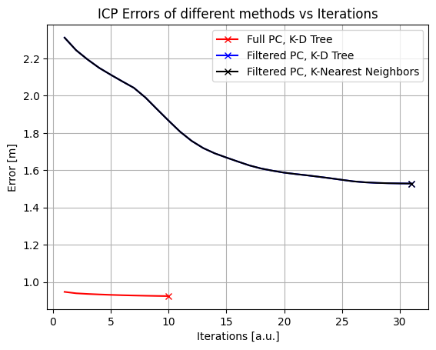

Figure - case 2 - ICP errors

The error plots of various methods were generated. These plots provide a more detailed understanding of the points discussed in the previous sections. In the filtered cases, the errors and convergence rates were identical, but there were variations in computational speed based on the data association method.

When comparing the full point cloud ICP to the filtered point cloud ICP, it is evident that the error remains relatively consistent across all iterations in the full PC ICP. As a result, the full PC ICP converges in fewer iterations compared to the filtered PC ICP. In addition the error is lower.

However, upon examining the final transformation results and the animation, it becomes apparent that the full point cloud (full PC) yields poor results compared to the filtered point cloud. This discrepancy is particularly noticeable in the translation vector result, where the displacement along the x-axis deviates approximately $\sim 0.8 [m]$ from the estimated distance in the case of the full PC, whereas the corresponding component in the filtered implementation is only around $\sim 6.7[m]$ which closely aligns with the initial approximation.

The reasons behind this can be primarily attributed to the factors discussed earlier, namely the presence of repetitive objects like the road and the fence alongside it, as well as dynamic objects. These elements contribute to point overlap and can lead to incorrect point associations.

In this scenario, it is much clearer that the filter is necessary for the improvement of the process. In addition, an dynamic object detection and filter based on the object bounding box could help as well.

#### "KISS-ICP" contributions

The paper "KISS-ICP: In Defense of Point-to-Point ICP - Simple, Accurate, and Robust Registration If Done the Right Way" makes several significant contributions to the ICP process, two of them are:

1. Most ICP variants utilize a maximum distance threshold in the data association module plus a robust kernel and a maximum number of iterations. In contrast, KISS ICP propose a **threshold estimation method that adapts to changing scenarios** by reasoning about the system kinematics and the nature of the data in combination with a robust kernel. This approach makes the algorithm to generalize better for different environments.

2. KISS ICP implementation depends on a small set of seven parameters - two parameters for the correspondence search, four for the map representation and scan subsampling, and one for the ICP termination. This approach makes the process easier to tuned and more efficient than before.

These contributions of the paper "KISS-ICP" offer valuable insights and advancements to the ICP process, simplifying the algorithm while improving its performance in terms of accuracy and robustness.

## Visual Odometry

The objective of this section is to implement a basic monocular visual odometry (VO) 2d->2d pipeline with key features including landmark initialization, keypoint tracking, pose estimation, extracting rotation and translation from the essential matrix, and refining the motion estimates. The assignment requires the use of prepared sub-functions, the KITTI visual odometry dataset, camera calibration, and the calculation of scale factors. The goal is to calibrate the algorithm to achieve a maximum Euclidean distance of 15 meters from the ground truth within the first 500 frames.

#### Monocular VO 2D->2D

##### Algorithm pipeline

* **Initialization** and **calibration**: extract the intrinsic and extrinsics matrices of the camera and initialize the first pose with the ground truth first pose corresponding to the first frame.
* **Feature detecting:** when new frame received, keypoints of the last and the current frames are extracted based on **SIFT** **(Scale-Invariant Feature Transform)** algorithm**. Keypints -** are specific locations in an image that have unique properties or characteristics. These points are selected because they represent distinctive regions, such as corners, edges, or blobs, that can be reliably detected and described. The SIFT algorithm works by identifying keypoints based on their stable and distinctive local image features. These keypoints are detected at different scales and orientations using a Difference of Gaussians (DoG) approach. Then, for each keypoint, a **descriptor** is computed based on the local image gradients, which captures the unique characteristics of the surrounding region.
* Therefore the main advantages of SIFT is:
* Individual features can be matched to a large database of objects
* Many features can be generated for even small objects
* Close to real-time performance
* Features are local, so robust to occlusion and clutter (no prior segmentation)
* **Feature Matching**: We need feature matching between the two frames to establish correspondences between the distinctive features enabling the motion estimation in the nexts steps. In this case the feature matcher use is – Brute Force feature matcher – simple and straightforward method for matching keypoints between images by exhaustively comparing each keypoint descriptor in one image with all the keypoints in another image using a distance metric, such as Euclidean distance or Hamming distance. In this case, a Knn was used to find the best K=2 matches per feature.
* **Matches filtering:** To remove unreliable matches obtained from the feature matcher, a filtering technique was employed using a ratio of 0.7. The best two descriptor distances identified by the matcher were taken into account. A lower descriptor distance indicates a better match. Thus, any matches with a distance lower than 0.7 times the distance of the second-best descriptor were considered as good matches and retained for further processing.
* **Extract essential matrix:** calculation of the Essential matrix was performed by findEssentialMat() function of Opencv library. The function performing the following steps to find the essential matrix:
  + It computes the fundamental matrix, which represents the geometric relationship between the two camera views, using the matched points and the 8-point algorithm.
  + The essential matrix is derived from the fundamental matrix by incorporating the camera intrinsics.
  + RANSAC is applied to robustly estimate the essential matrix by iteratively selecting random subsets of point correspondences and calculating the essential matrix based on these subsets.
  + The estimated essential matrix is further refined by selecting the best subset of correspondences that maximizes the geometric consistency.

The resulting essential matrix represents the relative pose and orientation between the two camera views, taking into account the camera intrinsics.

* **Recover pose from the essential matrix**: Given the essential matrix, the function estimates the camera rotation ($R$) and translation ($t$) by utilizing the corresponding points in the previous and current frames. Here's how the function works:
  + It performs a decomposition of the essential matrix to obtain four possible combinations of rotation and translation, resulting in four possible camera poses.
  + For each possible pose, it triangulates the 3D points using the matched points and computes the depth of each point.
  + The pose with the most positive depth points is considered as the correct pose, as it ensures that the reconstructed points are in front of both camera views.
  + The function returns the correct camera rotation (R), translation (t), and the number of inliers used in the pose recovery process.
* **Compute scale factor**: the scale factor is computed to update the translation component recovered from the essential matrix. The reason for computing this scale factor is to determine the correct magnitude or scale of the translation between consecutive camera frames.
$$scale=\frac{|GT_{i}-GT_{i-1}|}{|VO_{i}-VO_{i-1}|}$$

* **Update transformation:** To determine the current position, it is necessary to update the previously computed rotation and translation values using the recovered rotation ($R$ ``) and translation ($t$ ``). This updating process incorporates the new information obtained from the pose estimation to refine and adjust the camera's position and orientation considering the computed scale factor.

$$R_{updated}=R_{recovered}R_{current}$$

$$t_{updated}=scale*R_{recovered}t_{current}+t_{recovered}$$

Finally the (x,y,) position can be taken from the translation vector $t$ based on the (x,z) coordinates (camera coordinates system).

##### Example Frame – 500:

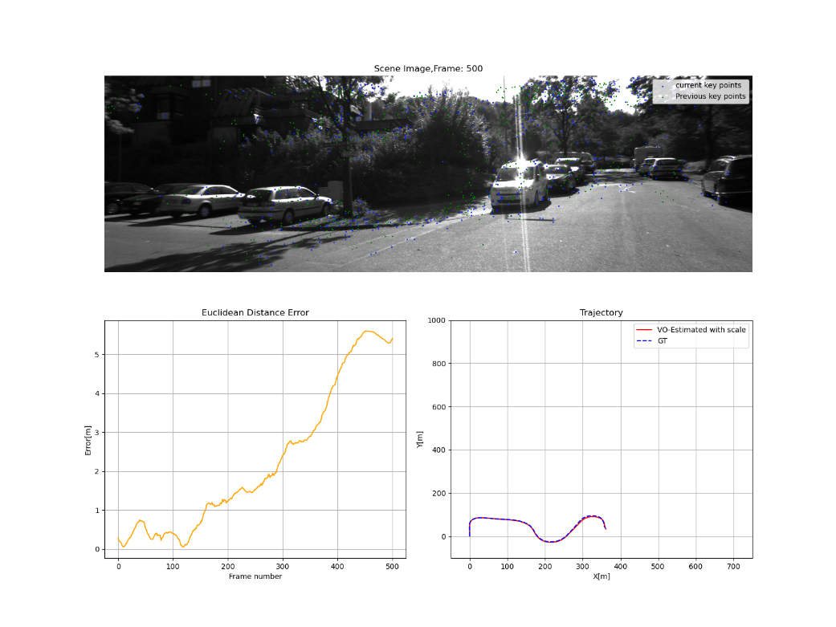

Figure - Frame 500 , GT vs. Estimation

Based on the figure displayed above, it is evident that the error requirements of being less than 15 meters before frame 500 have been met. This indicates that the VO algorithm has been calibrated sufficiently well. Error received was 5.4[m]. Based on the error plot, it is apparent that there is a slight increase in the error, which could be attributed to the accumulation of errors during the turns, it is possible for the visual odometry of a monocular camera to experience increased error during vehicle turns. This can happen due to various factors such as motion blur and light changes when the scene geometry is distorted during turns.

#### Analysis

##### Animations

An animation showcasing the ground truth and estimated trajectory, computed using the pipeline described above, has been generated.

The animation depicts the trajectory of the vehicle, which is determined using a camera and grayscale images captured by it. Throughout the journey, the algorithm focuses on key points, predominantly found on trees, bushes, parked vehicles, buildings, sidewalks, as well as on the road and moving objects like cars and motorcycles.

##### Results

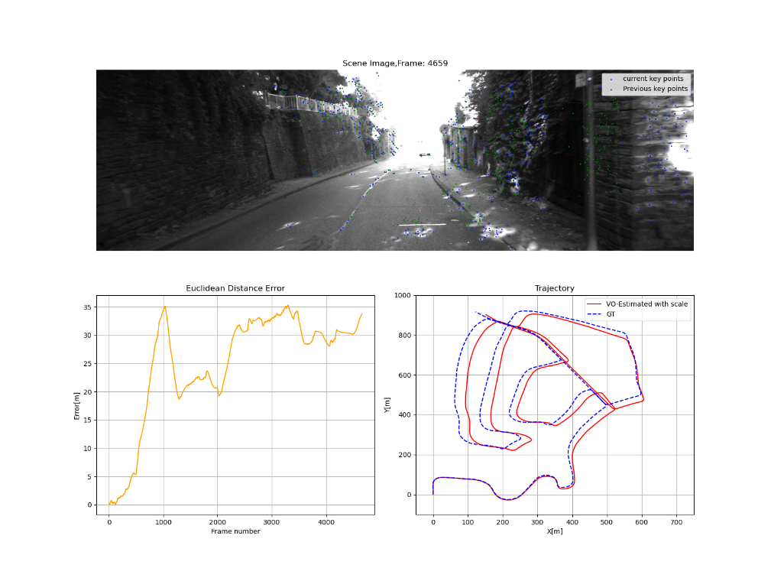

Figure - Last frame

By observing the figure provided, it becomes evident that there is a progressive error between the ground truth (GT) and the estimated trajectory as the vehicle progresses. This accumulation of errors ultimately results in a final error of approximately 33 meters on the last frame of the scenario. It is reasonable to expect that the error may increase during the visual odometry process. Several factors can contribute to this, such as inaccuracies in feature matching, noise in sensor measurements, environmental changes, light changes and uncertainties in the motion estimation algorithms. These factors can cumulatively lead to an accumulation of errors and potentially result in an increase in the overall error of the visual odometry system.

In our scenario, it is evident that there are numerous turns along the path. As mentioned earlier, these turns can contribute to the occurrence of drift phenomena.

Furthermore, as previously mentioned, a substantial number of keypoints were extracted from areas suchas the road, sky, and walls, which lack unique structures and often exhibit repetitive patterns. This characteristic can contribute to an increase in error during the visual odometry process. We can see an example for that on the figure below, where is a bunch of keypoints distributed on the road:

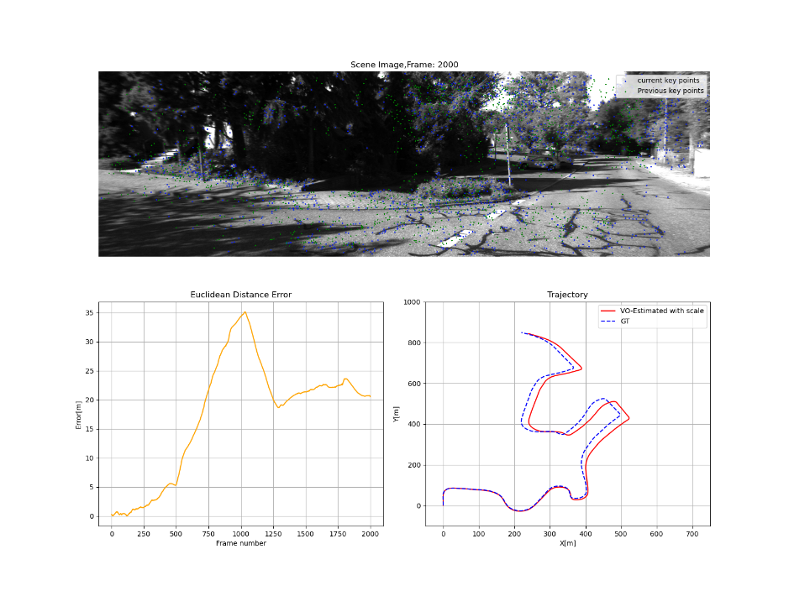

Figure - Frame 2000

Another reason mentioned can be light conditions such as variations in brightness, shadows, or strong reflections, those can adversely affect the performance of visual odometry algorithms due to difficulties in feature extractiong. In our scenario there are a lot of examples for this, one of them can be found on the figure below:

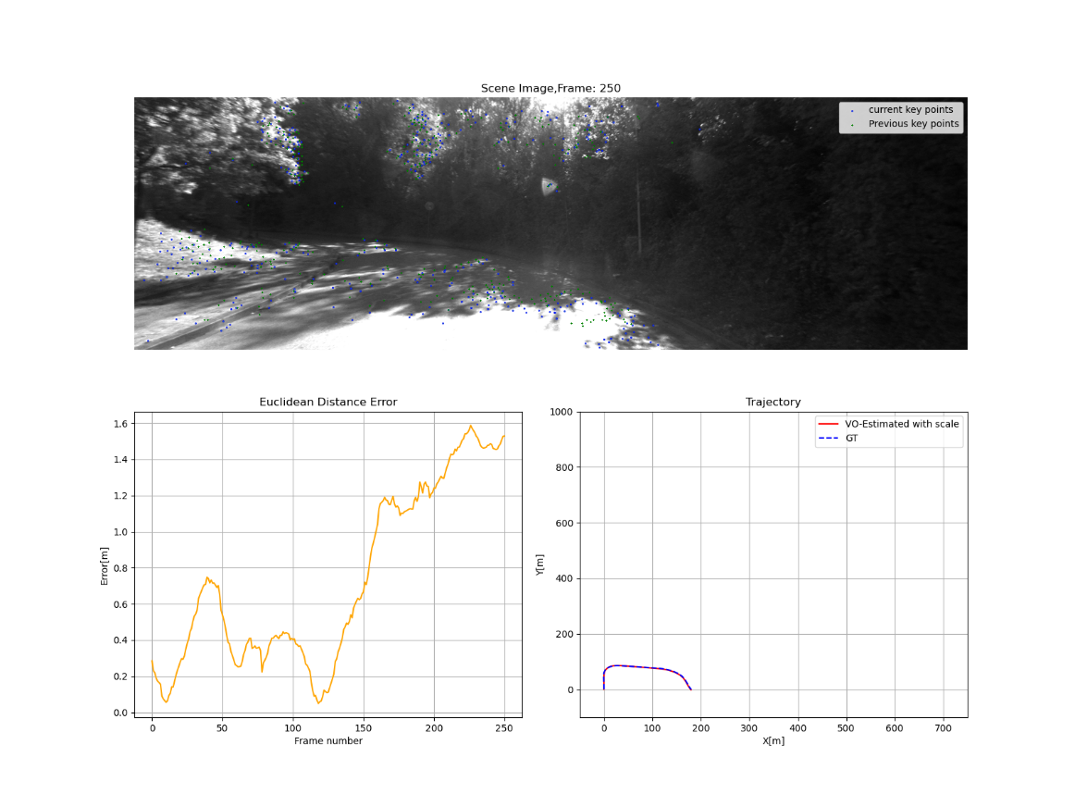

Figure - Frame 250

In general, the basic algorithm for 2D visual odometry, given the circumstances of environmental conditions and the algorithm's simplicity, performed reasonably well. However, its effectiveness was limited in terms of long-term usage. Based on the basic implementation, there are numerous enhancements that can be developed. Several improvements were discussed in the following section.

##### Improvements suggestions

In addition to calibrating the algorithms used, such as SIFT, BFmatcher, and the Essential matrix finder, which have a few adjustable parameters, here are three suggested improvements:

1. Loop Closure: Implementing loop closure techniques can improve visual odometry by detecting and handling repeated or revisited scenes. By recognizing previously visited locations, the algorithm can correct accumulated errors and refine the trajectory estimation. This can be achieved through methods such as bag-of-words (the known rtab-map algorithm), place recognition, or graph-based approaches. **In this case,** in the provided figure depicting the overall trajectory, it is evident that the vehicle revisited certain points it had previously traversed (blue arrows), so it suggests that there is a possibility of improving the algorithm by incorporating loop closure and by that, reducing the drift and improve the localization.

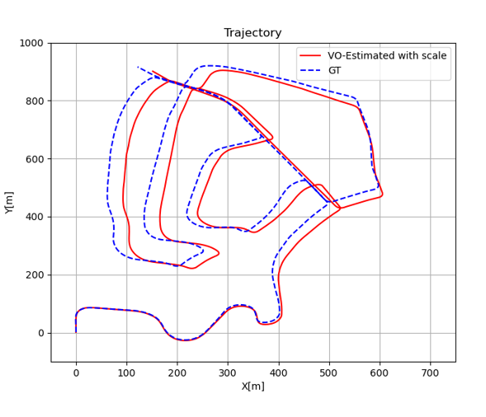

2. Dynamic Object Detection: Incorporating dynamic object detection into visual odometry can enhance its performance in environments with moving objects, such as vehicles or pedestrians. By identifying and tracking these dynamic objects separately from the static background, the algorithm can mitigate their influence on the odometry estimation. This can involve techniques like motion segmentation, object tracking, or deep learning-based object detection. **In this case** a motor-cycle for example from frame 1050.

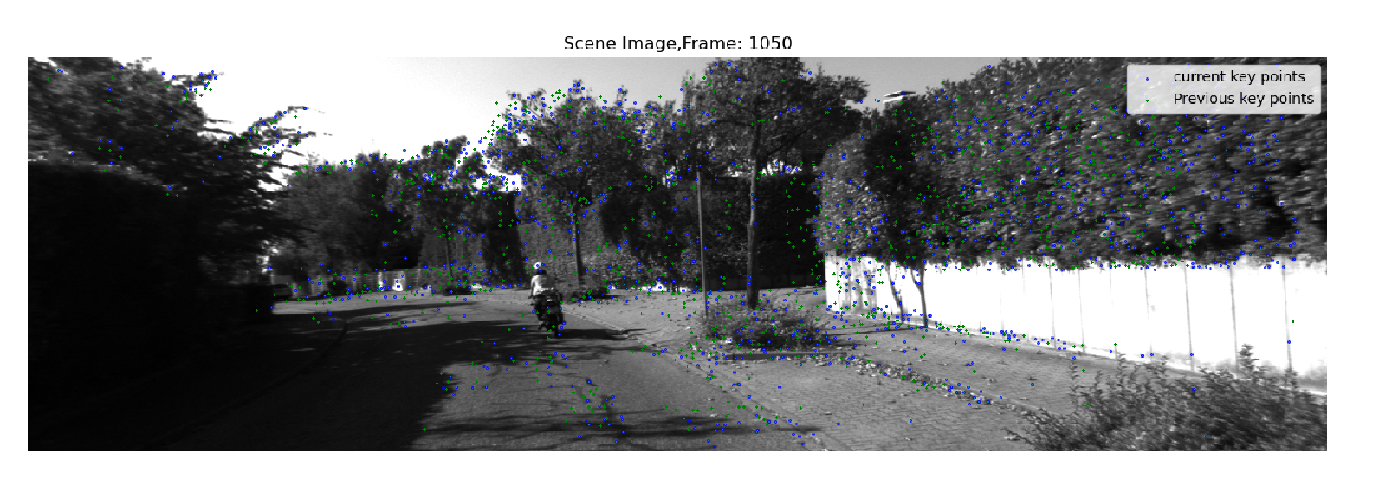

Figure - Dynamic object example

3. Road and Sky Segmentation: Accurate segmentation of road and sky regions from the visual input can assist visual odometry algorithms in robust pose estimation. By excluding the road and sky regions we can eliminate noisy or irrelevant information. Techniques like semantic segmentation, image thresholding, or model-based segmentation can be employed for this purpose.

**In this case** for example from frame 3550:

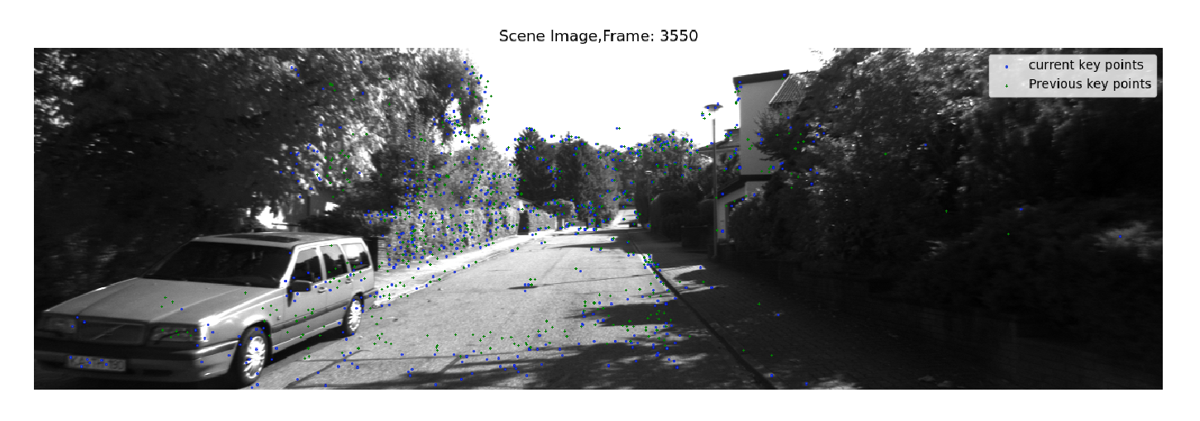

Figure - Repeatative regions filtering example

Integrating these improvements into the visual odometry algorithm described in the provided code can enhance its accuracy, robustness, and resilience to challenging scenarios. Loop closure can reduce drift and correct errors, dynamic object detection can handle moving objects' presence, and road and sky segmentation can improve feature extraction and filtering, leading to more accurate pose estimation and overall improved performance.

# Summary

In this assignment, three important techniques—Particle Filter, ICP, and Visual Odometry—are explored. The Particle Filter section focuses on estimating the robot's pose using motion model predictions and sensor measurements, the minimal set of the particles for our data was found and pros and cons of the algorithm were discussed as well. The ICP section involves aligning two scans using different mechanisms and evaluating their performance, two different scenarios were analyzed and we could notice the difference of the operation of the algorithm in relation to each case and each method. Lastly, the Visual Odometry section aims to develop a pipeline for estimating camera motion and analyzing the results. Overall, the assignment provides hands-on experience with these techniques and encourages the exploration of improvements to enhance mapping and localization in robotics.

**THANKS!**